Mandatory Python tasks – Pentest
- XOR Pairs
CODE:
def find_xor_pairs(arr, target):
seen = set()
pairs = set()

for num in arr:
complement = num ^ target
if complement in seen:
# Sort the pair to ensure (a, b) and (b, a) are treated as the same
pair = tuple(sorted((num, complement)))
pairs.add(pair)
seen.add(num)

return list(pairs)

l= list(eval(input("enter the list of numbers")))
target = int(input("enter the target"))
print(find_xor_pairs(l, target))

OUTPUT:
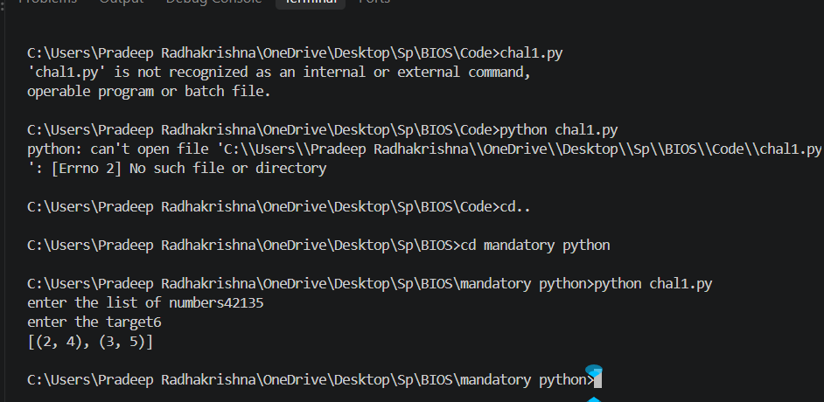
- Finding the second max and min
CODE:
def find_second_extremes(arr):
if len(arr) < 2:
return "Array must have at least two elements"

# Initialize using the first element of the array
first_max = arr[0]
second_max = None

first_min = arr[0]
second_min = None

for num in arr:
#Finding the maximum
if num > first_max:
second_max = first_max
first_max = num
elif num != first_max and (second_max is None or num > second_max):
second_max = num

#Finding the minimum
if num < first_min:
second_min = first_min
first_min = num
elif num != first_min and (second_min is None or num < second_min):
second_min = num

return {
"second_largest": second_max,
"second_smallest": second_min
}

l= list(eval(input("enter the list of numbers")))
result = find_second_extremes(l)
print("Result:", result)

OUTPUT:
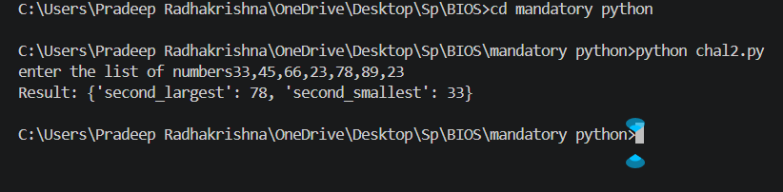
- Reversing only the alphabets
CODE:
def reverse_alpha(s):
chars = list(s)
alphabets = []
for c in chars:
if c.isalpha():
alphabets.append(c)

alphabets.reverse()

alpha_idx = 0
for i in range(len(chars)):
if chars[i].isalpha():
chars[i] = alphabets[alpha_idx]
alpha_idx += 1

final_string = "".join(chars)
return final_string

s = input("enter the string")
print(reverse_alpha(s))

OUTPUT:
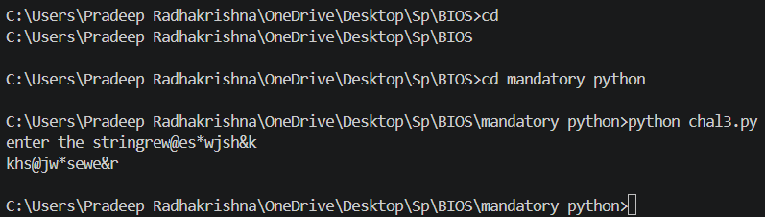
- Check for anagrams
CODE:
def anagrams(str1, str2):
if len(str1) != len(str2):
return False

count1 = {}
count2 = {}

#Counting the characters in the first string
for char in str1:
if char in count1:
count1[char] += 1
else:
count1[char] = 1

#Counting the characters in the second string
for char in str2:
if char in count2:
count2[char] += 1
else:
count2[char] = 1
return count1 == count2
w1 = input("enter the first word")
w2 = input("enter the second word")
print(anagrams(w1,w2))

OUTPUT:
